WEBSITE PROJECT

IMAGE FILE:

Roundlogo

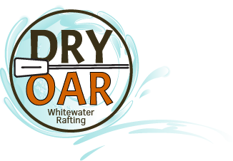

COLORS:

* primary-color = 99E2FF (non photo blue)
* secondary-color == 472E0B (café noir)
* accent1-color == C86304 (alloy orange)
* accent2-color == 57A773 (jade)

https://coolors.co/99e2ff-c86304-8e6c88-57a773-472e0b

FONTS:

* heading-font – Noto Serif
* text-font - Inter